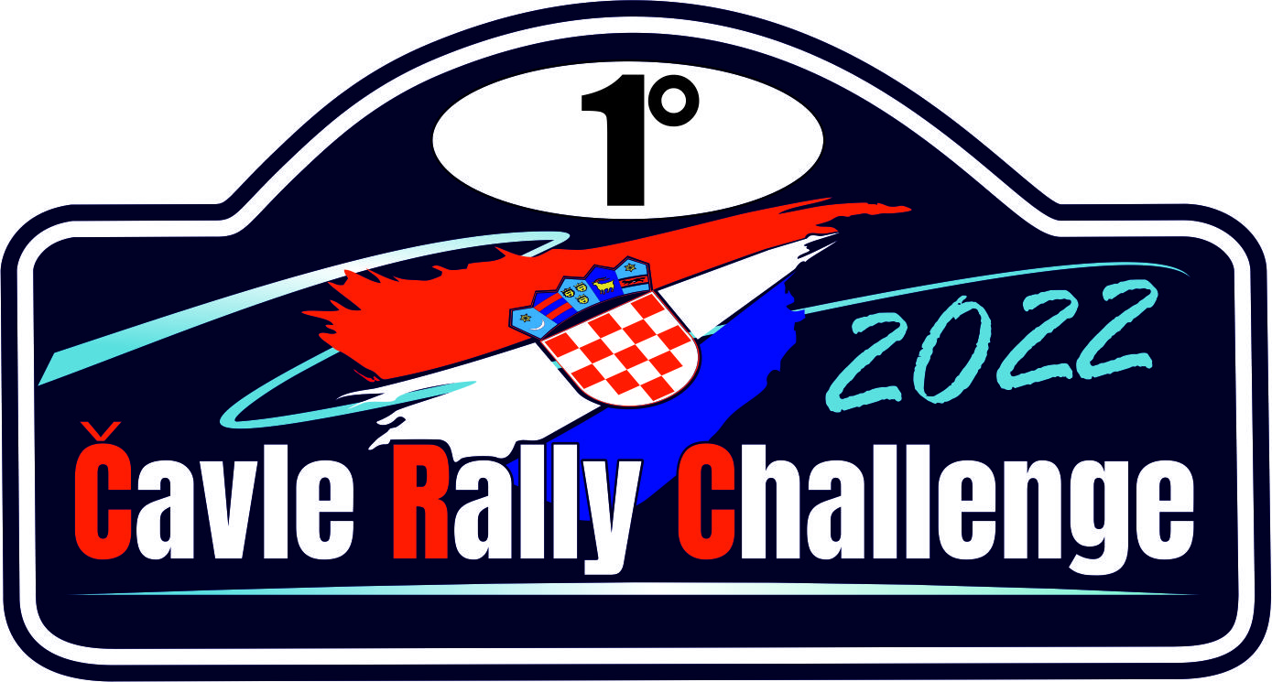

ACCREDITATION FORM FOR JOURNALIST

Name and Surname
Editorial office
Newspaper |  | Radio |  |  | Internet |  |  |  | TV
Journalist |  |  | Fhotoreporter |  |  |  | Kameraman
Address
Phone / Mobile
Fax
E-mail
Web site

RALLY HQ, AUTOMOBILE CLUB ”POREČ MOTORSPORT” POREČ
HQ: Partizanska 5A,HR-52 440 Poreč
Tel: +385 95 368 86 30,Edi Milokanović
Internet address: http://rally-porec.eu

RALLY PRESS CENTER
Adress: Automotodrom Grobnik – Press – 1st floor
Office hours: 11.11.2022. from 08:00 till 18:30
12.11.2022. from 08:00 till 19:30
E-mail: rallycavlepress@gmail.com
Contact: Marko Šivak +385/91/634 89 03

Advance payment for press marker in the amount of :

Place and date: |  | Signature:

By signing this form, I agree to participate in the competition in my own risk!

